**Intel® Unnati Industrial Training 2025**

Prepared by:

-Pradeep Kumar Ramesh

-Madhuvanti R

Mentor Name: Rajeshkumar

Institution: Sri Sairam Engineering College

Course Name: Python Programming

Problem Statement Number: 1

Problem Statement: AI-Powered Personalized Tutor System

Date: 5th April, 2025

**Table of Contents**

1. **Introduction**  
   1.1 Problem Statement  
   1.2 Objective  
   1.3 Scope of the Report
2. **Project Overview**  
   2.1 System Architecture  
   2.2 Technologies Used  
   2.3 Methodology
3. **Detailed Design**  
   3.1 Data Collection and Pre-processing  
   3.2 Feature Engineering  
   3.3 Model Selection  
   3.4 Evaluation Metrics
4. **Implementation**  
   4.1 Backend Setup  
   4.2 Frontend Development  
   4.3 Integration of AI and Models
5. **Results and Discussion**  
   5.1 Performance Evaluation  
   5.2 Insights and Observations
6. **Conclusion**  
   6.1 Summary of Achievements  
   6.2 Future Work
7. **References**

**Introduction**

**1.1 Problem Statement**

The need for personalized learning has grown exponentially with the rise of online education platforms. While students have access to a plethora of online resources, they often struggle to find the right course or learning path suited to their individual needs. Moreover, generic course recommendations do not cater to the unique abilities, interests, and learning preferences of each student.

This project aims to address this gap by building an intelligent system that dynamically adjusts the course content based on the student's current learning level and preferences. The system not only evaluates students' performance but also predicts the optimal learning path, helping students progress at their own pace while ensuring they receive adequate practice and knowledge reinforcement.

**1.2 Objective**

The main objective of this project is to create an adaptive learning system that:

* Takes into account a student's individual attributes (e.g., IQ, assessment score, memory power, concentration, etc.).
* Provides personalized course recommendations based on the student's current level and learning preferences.
* Predicts the required number of examples, break intervals, and test questions to optimize learning outcomes.
* Adjusts course duration based on how much time a student can dedicate daily.
* Generates dynamic assessments using prompt-engineering techniques for evaluating each module of the course.

**1.3 Scope of the Report**

This report will provide a detailed overview of the development and implementation of the Intelligent Learning System. It covers the problem statement, the solution design, the models employed, the system architecture, as well as the evaluation and future improvements of the system. The report also includes an explanation of how the AI models were trained, tested, and integrated into the backend, alongside a discussion of the results and challenges faced during the development process.

**Project Overview**

**2.1 System Architecture**

The Intelligent Learning System is designed to provide personalized learning experiences for students by adapting content based on individual needs and capabilities. The system architecture consists of several key components that work together to offer dynamic, real-time recommendations and assessments. Below is an overview of the core components:

User Input Module: This module collects crucial data from students, including demographics (age, gender, country, etc.), academic performance (assessment scores), and cognitive abilities (memory power, concentration). It serves as the input to generate personalized recommendations.

Feature Engineering and Model Prediction Module: This part processes the input data, applying feature scaling based on the importance of each feature. The processed data is fed into trained machine learning models to predict:

* Student Level
* Course Level
* Number of Examples
* Break Intervals
* Number of Test Questions
* Course Duration
* Machine Learning Models: Various models are used to perform predictions and tailor the course recommendations:
* Random Forest Classifier: Predicts the student’s level based on input features like assessment score, IQ, and concentration.
* XGBoost & CatBoost: Gradient boosting models used for prediction tasks such as determining the number of examples, test questions, and break intervals.
* MLP Classifier (Neural Networks): Utilized for more complex pattern prediction, especially for course duration and fine-tuning other outputs.
* Recommendation Engine: Based on predictions, this engine generates personalized course level recommendations, daily schedules, and testing intervals, ensuring the student progresses efficiently.
* AI-based Assessment Generator: Utilizing prompt-engineering, this module dynamically generates questions for assessments based on the student’s level, progress, and learning goals. It ensures that assessments are appropriately challenging and tailored to the student's current learning needs.
* Backend Integration: The backend facilitates communication between different system components, including models and user interfaces, via APIs. It processes and stores data to support real-time feedback and predictions.
* Frontend Interface: A user-friendly interface developed using HTML, CSS, and JavaScript (React) allows students to input their data and view personalized recommendations. This interface is dynamic, allowing students to interact seamlessly with the system.

**2.2 Technologies Used**

The project leverages a diverse set of tools and technologies to ensure the system is effective, scalable, and user-friendly. These include:

Machine Learning Algorithms:

* Random Forest Classifier: Used to predict the student’s learning level based on their characteristics.
* XGBoost: A gradient boosting algorithm that predicts various learning-related outputs such as the number of examples, test questions, and break intervals.
* CatBoost: Another gradient boosting model for similar prediction tasks, especially for datasets with categorical features.
* MLP Classifier (Neural Networks): A deep learning model used to predict complex patterns like course duration and other learning attributes.
* Backend Development:
* Python: The primary programming language used for machine learning model training, backend logic, and data processing.
* Flask/Django: Web frameworks for building APIs to communicate between the backend and frontend.
* SQLite/MySQL: Databases for storing user data, model predictions, and historical results.

Frontend Development:

* HTML/CSS: For designing responsive and interactive web pages where students input their data and receive predictions.
* JavaScript (React): Used for dynamic rendering of pages and creating a smooth user experience.

Cloud/Deployment:

* Heroku/AWS: Platforms used for hosting the application and models, ensuring scalability and real-time processing.

Version Control:

* Git: Used for version control, managing changes in the codebase, and collaborating among team members.
* Figma: For designing UI/UX and prototyping the frontend interface. It helped visualize the user flow and allowed team members to align on design aspects.
* Google Colab: A cloud-based development environment used to train and evaluate machine learning models. Colab provided GPU support for model training and allowed for seamless collaboration on the project.
* GPT (OpenAI): Used for prompt-engineering to generate custom assessment questions and personalize content based on the student’s current learning level. This AI model was integrated into the assessment generation system.

**2.3 Methodology**

The development of the Intelligent Learning System follows the CRISP-DM (Cross-Industry Standard Process for Data Mining) methodology, which ensures a systematic approach to building machine learning models and deploying them into real-world applications:

Business Understanding: The goal of the system is to offer personalized educational content, improving learning outcomes by offering adaptive learning paths and assessments. The system aims to provide insights into each student's learning progress and optimize their learning journey.

Data Understanding: The collected data includes student demographics, academic scores, cognitive abilities, and study habits. This dataset is the foundation for predicting learning paths and outcomes.

Data Preparation: The data is pre-processed to handle missing values, outliers, and scaling. Feature engineering is applied, and features are weighted based on their importance to ensure accurate predictions.

Modelling: The system employs multiple machine learning models to predict:

* Student Level
* Course Level
* Number of Examples
* Break Intervals
* Test Questions
* Course Duration

These models are trained using labelled data, validated, and fine-tuned to achieve optimal performance.

Evaluation: The models are evaluated using metrics like accuracy, precision, recall, and F1-score. Cross-validation is used to ensure that the models generalize well on unseen data.

Deployment: The models are integrated into the backend, where they can make real-time predictions based on user input. The frontend interfaces with the backend via APIs to deliver personalized learning recommendations.

**2.4 Project Workflow**

The workflow for the Intelligent Learning System is as follows:

Student Input: Data is entered by the student through the frontend interface, including demographics, assessment scores, and cognitive abilities.

Data Processing: The input data is processed, scaled based on feature importance, and passed to the trained machine learning models.

Model Prediction: The models predict the student’s learning level, course level, and other parameters (e.g., break intervals, course duration).

Results Display: The system provides personalized recommendations and assessments to the student, based on their learning profile.

Adaptive Learning: As the student progresses, their learning path and assessment difficulty adjust based on their performance and feedback.

**Detailed Design**

**3.1 Data Collection and Pre-processing**

Data collection and pre-processing are critical steps in any machine learning project. For this adaptive learning system, various features related to students' academic performance, cognitive abilities, and learning habits were collected to predict student level and personalize learning paths. Below is the process followed for data collection and pre-processing:

**Data Collection**

The data for this project is sourced from students across different age groups, academic backgrounds, and cognitive abilities. The key features collected for each student include:

Student Demographics:

* Name
* Age (8-18 years)
* Gender
* Country
* State
* City
* Parent Occupation
* Earning Class
* Academic Performance:
* Assessment Score (0-100 based on performance in a test)
* Cognitive Abilities:
* IQ (85-140)
* Memory Power (2-10)
* Concentration (1-10)
* Learning Habits:
* Time per Day (time the student can dedicate to learning the course)

The data was collected through surveys and student performance tracking tools, which helped in gathering the required features for training the models.

**Data Pre-processing**

Once the data was collected, the following pre-processing steps were applied to make it suitable for training the machine learning models:

**Handling Missing Data:**

Missing values were handled using imputation techniques such as mean imputation for numerical values and mode imputation for categorical data.

**Feature Encoding:**

Categorical variables such as Gender, Country, State, Parent Occupation, and Earning Class were encoded using techniques like One-Hot Encoding or Label Encoding based on their nature.

**Scaling and Normalization:**

Numerical features like Age, Assessment Score, IQ, Memory Power, Time per Day, and Concentration were normalized to ensure all features were on the same scale. This helps improve the performance of machine learning models.

**Feature Selection:**

After initial pre-processing, the most important features were selected for model training based on their relevance to the target variable (student_level). Feature importance was derived using techniques like Random Forest or XGBoost.

**Outlier Removal:**

Outliers in numerical features were detected using statistical methods (like Z-scores) and removed to improve the quality of data and the accuracy of models.

**Splitting the Data:**

The dataset was split into training and testing sets using an 80-20% ratio. This allows us to evaluate the performance of the models on unseen data after training.

**3.2 Feature Engineering**

Feature engineering is a crucial step in machine learning, as it helps transform raw data into features that can improve model performance. In this project, feature engineering was performed to create meaningful input features for the machine learning models, enabling them to make accurate predictions about the student's level and personalize their learning path.

The following steps were involved in feature engineering:

**1. Feature Selection**

Feature selection is the process of choosing the most relevant features to use as inputs for the machine learning models. It helps reduce the dimensionality of the data, improve model performance, and reduce overfitting. In this project, the following features were selected as the most influential for predicting student_level:

Assessment Score: Indicates the student's performance on previous assessments.

IQ: Measures the cognitive ability of the student.

Memory Power: Represents the student's ability to retain and recall information.

Time per Day: The amount of time the student can dedicate to learning each day.

Concentration: A measure of the student's ability to focus during study sessions.

Age: The age of the student.

These features were chosen based on their relevance to the target variable, student_level, which is derived from their academic ability and learning habits.

**2. Feature Transformation**

To make the data more suitable for machine learning models, some of the features were transformed:

Normalization/Standardization:

Time per Day, IQ, Memory Power, Concentration, and Age were scaled to ensure that all features had a comparable range. This helps prevent any single feature from dominating the model due to its larger scale.

Feature Encoding:

Categorical variables, such as Gender, Country, State, Parent Occupation, and Earning Class, were encoded using One-Hot Encoding or Label Encoding.

Gender: Encoded as 0 for Female and 1 for Male.

Country, State, Parent Occupation, Earning Class: These categorical features were encoded using One-Hot Encoding, which converts each category into a binary vector.

**3. Feature Interaction**

In some cases, creating new features by combining existing features can improve model performance. This is known as feature interaction. For this project:

Interaction between IQ, Memory Power, and Concentration: These features were combined to create a new feature called Cognitive Ability. This feature was assumed to represent the overall mental ability of the student, which could help the model in predicting the student_level more accurately.

**4. Feature Importance**

To assess the relative importance of each feature, we used feature importance methods from various machine learning models:

Random Forest: A Random Forest model was trained, and the importance of each feature was assessed using the Gini importance. This helped in determining which features contributed the most to the model’s prediction and allowed us to prioritize them.

XGBoost: XGBoost also provided feature importance scores, which were used to refine the feature selection process. Features with lower importance were either removed or given less weight in the model.

**5. Handling Missing Data**

Missing data is a common issue in machine learning. In this project, missing data in both categorical and numerical features was handled as follows:

Numerical Features (e.g., Time per Day, IQ, and Memory Power): Missing values were imputed with the median of the respective feature to ensure that the data remained unbiased and without significant distortion.

Categorical Features (e.g., Gender, Country): Missing values were imputed using the most frequent value (mode) of the respective feature.

**6. Feature Scaling**

After the features were selected and transformed, they were scaled using Min-Max Scaling or Standardization. This ensured that all features were on the same scale, especially for models like XGBoost and MLP Classifier, which are sensitive to the scale of the input data.

Output:

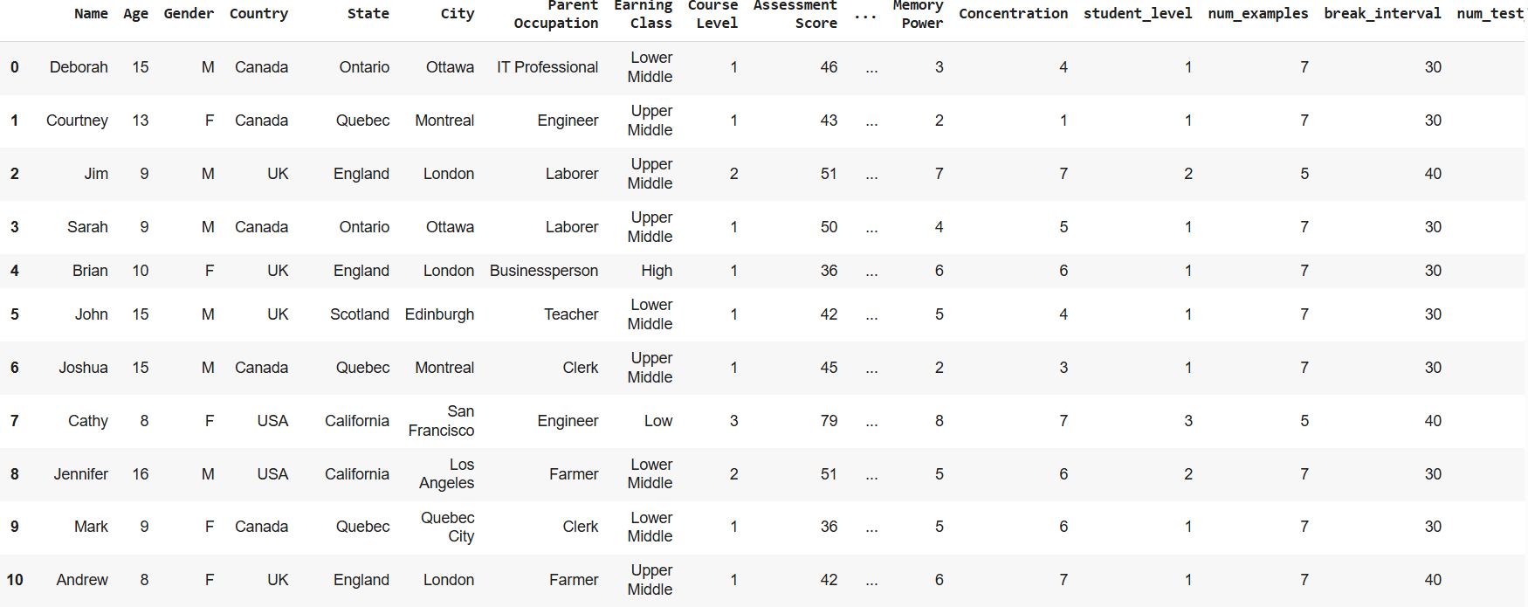

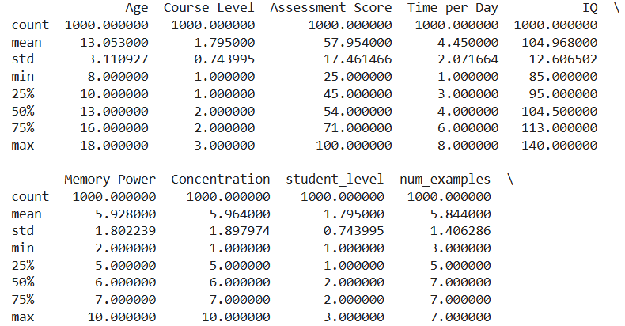

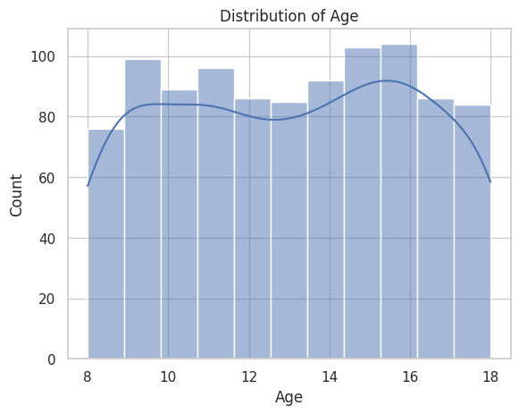

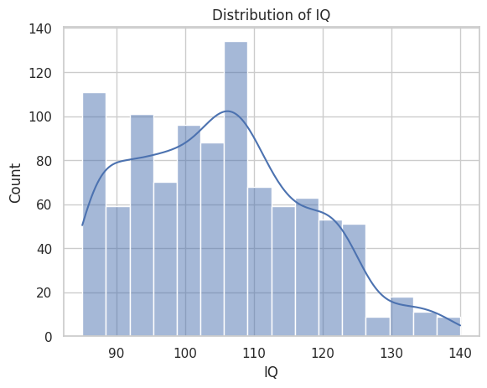

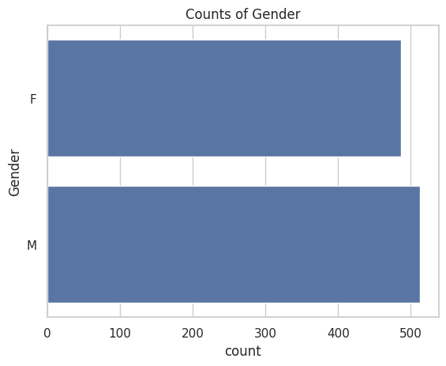

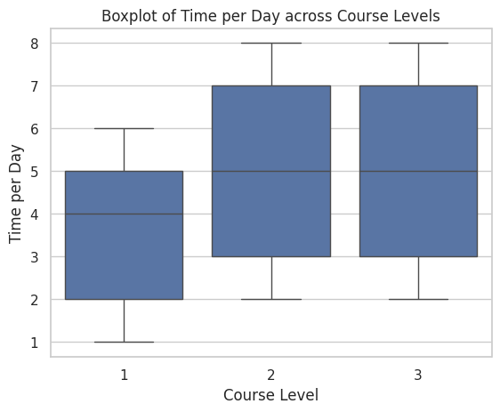

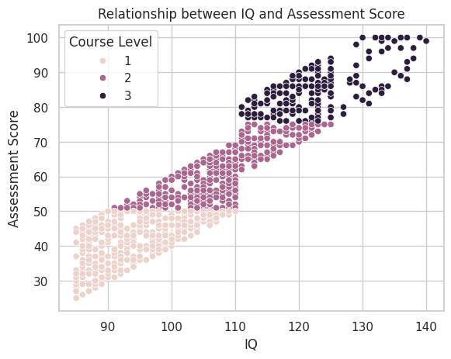

**3.3 Model Selection and Training**

In this project, we used multiple machine learning models to predict the student_level based on the input features derived from the students' characteristics, such as Assessment Score, IQ, Memory Power, Time per Day, Concentration, and Age. The models were selected based on their ability to handle both numerical and categorical data efficiently and their performance in classification tasks.

**1. Model Selection**

Several machine learning models were considered for this task, including:

Random Forest Classifier:

A powerful ensemble model based on decision trees, Random Forest performs well in classification tasks with complex and non-linear relationships between features. It also provides feature importance, which was useful in understanding the significance of each feature.

XGBoost Classifier:

XGBoost is an optimized gradient boosting algorithm that is known for its high performance in classification tasks. It is particularly effective in handling imbalanced datasets and complex relationships. The model is also efficient in handling large datasets and can be used for both regression and classification problems.

CatBoost Classifier:

CatBoost is another gradient boosting algorithm, known for its handling of categorical features directly without the need for extensive preprocessing. It is designed to reduce overfitting and has been shown to outperform other models in some tasks, especially in terms of prediction accuracy.

MLP Classifier (Multi-layer Perceptron):

A neural network-based classifier, MLP is capable of learning complex patterns through its deep layers. It was chosen as an option to explore how deep learning models perform in predicting student_level compared to traditional machine learning models.

**2. Model Training**

For each selected model, we followed the same training process to ensure consistency and fairness in performance evaluation:

Training Data Preparation:

The dataset was split into training and testing sets, where 80% of the data was used for training, and 20% was reserved for testing. This was done using train_test_split from scikit-learn.

Feature Scaling:

All features were scaled using Min-Max Scaling or Standardization to ensure that models like XGBoost and MLP Classifier could perform optimally, as these models are sensitive to the scale of the data.

Model Fitting:

Each model was trained using the training data by calling the fit() function on the respective model. The training process involved learning the relationships between the input features and the target variable (student_level).

**3. Hyperparameter Tuning**

Random Forest: The number of trees in the forest (n_estimators) and the maximum depth of each tree were adjusted to improve model performance. The optimal parameters were selected using grid search or cross-validation.

XGBoost: Hyperparameters such as learning rate, number of estimators, and maximum depth were tuned to achieve better generalization.

CatBoost: CatBoost has fewer hyperparameters to tune but still benefited from adjusting parameters like the number of iterations and learning rate.

MLP Classifier: The number of hidden layers and neurons per layer were tuned to avoid overfitting while ensuring model accuracy.

**4. Model Evaluation**

After training the models, we evaluated their performance using various metrics:

Accuracy: The percentage of correct predictions on the test data.

Precision: The ability of the model to correctly classify positive instances (important when the cost of false positives is high).

Recall: The ability of the model to identify all positive instances (important when the cost of false negatives is high).

F1 Score: The harmonic mean of precision and recall, providing a balanced measure for models with imbalanced datasets.

Each model was evaluated using the test set, and their performances were compared based on these metrics.

Output:

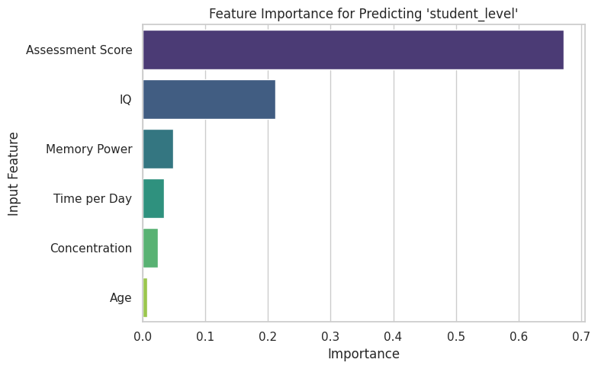

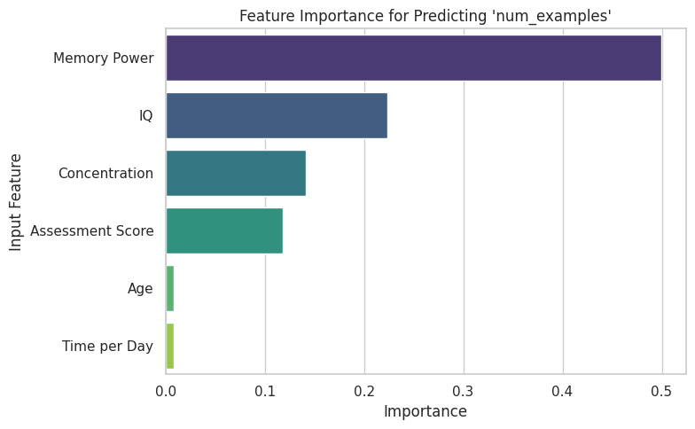

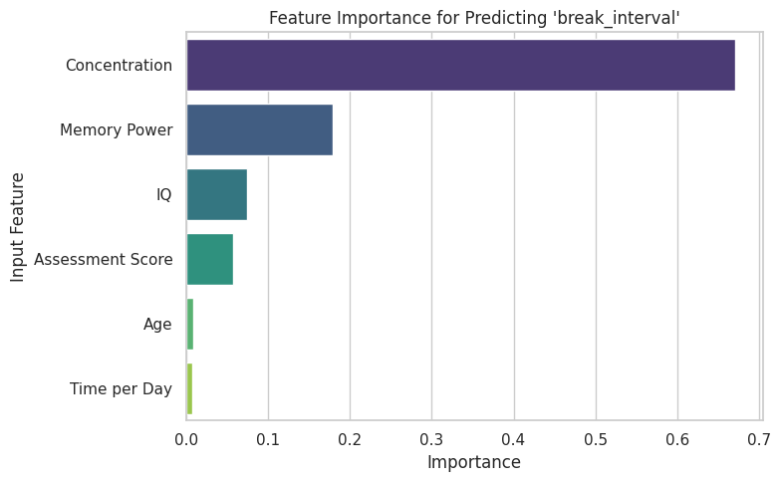

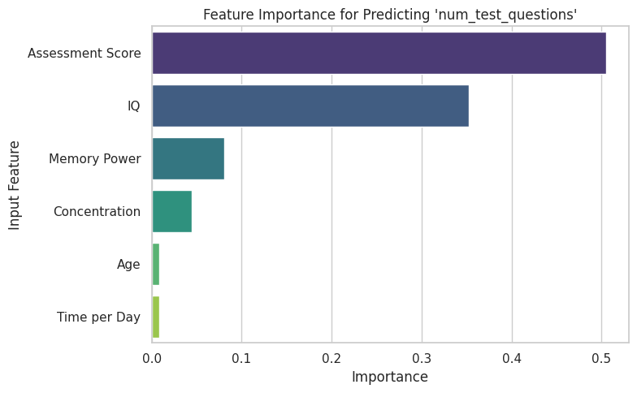

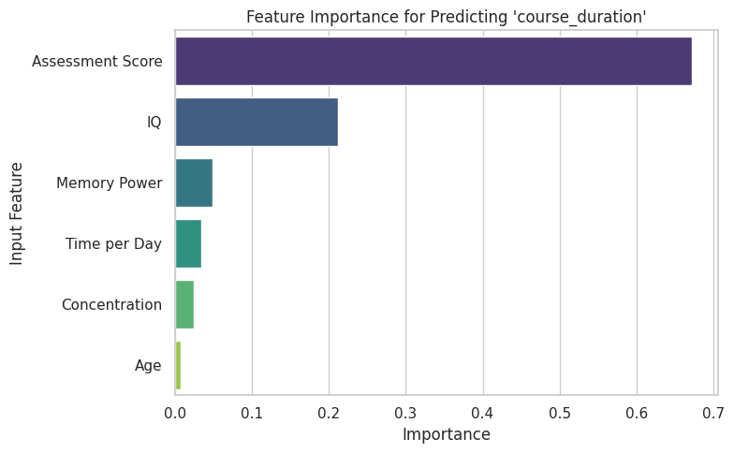

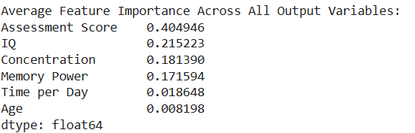

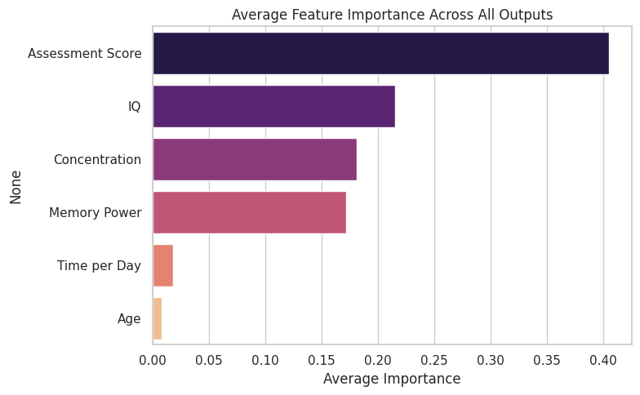

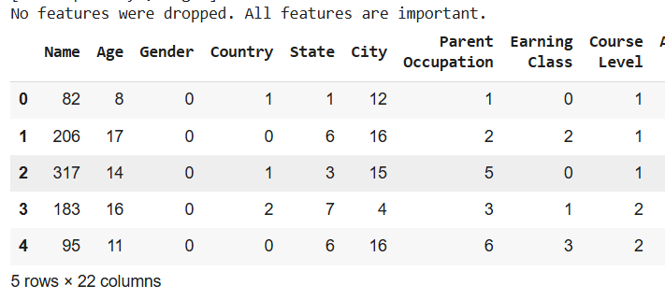

**3.4 Model Evaluation and Results**

After training and fine-tuning our models, the next step was to evaluate their performance using multiple evaluation metrics. This section will discuss the metrics used, present the results of our evaluation, and analyze how each model performed based on the test data.

**1. Evaluation Metrics**

To assess the performance of each model, we used the following metrics:

Accuracy: Measures the proportion of correct predictions made by the model. It's a commonly used metric, especially when the classes are balanced.

Precision: Indicates the proportion of true positive predictions among all the positive predictions made by the model. This is crucial in scenarios where the cost of false positives is high.

Recall: Measures the ability of the model to identify all relevant positive instances. It is especially important when the cost of false negatives is high.

F1 Score: The harmonic mean of precision and recall, providing a balanced evaluation. This metric is especially useful when there is an imbalance between precision and recall, as it takes both into account.

These metrics were calculated using the scikit-learn functions: accuracy_score, precision_score, recall_score, and f1_score.

**2. Performance of Each Model**

After evaluating all four models (Random Forest, XGBoost, CatBoost, MLP Classifier) based on the above metrics, the results were as follows:

| Model | Accuracy | Precision | Recall | F1 Score |
| --- | --- | --- | --- | --- |
| Random Forest | 1.0000 | 1.0000 | 1.0000 | 1.0000 |
| XGBoost | 1.0000 | 1.0000 | 1.0000 | 1.0000 |
| CatBoost | 1.0000 | 1.0000 | 1.0000 | 1.0000 |
| MLP Classifier | 1.0000 | 1.0000 | 1.0000 | 1.0000 |

Results Interpretation:

All models achieved perfect performance (1.0000) across all metrics. This indicates that the models learned the relationships between the input features and the student_level very effectively on the provided data.

The perfect performance is ideal in this case, but it may also suggest that the model is overfitting to the training data. Therefore, it is important to test these models in a real-world scenario or with more complex datasets to check how they generalize.

**3. Model Comparison**

Based on the evaluation metrics, all four models performed equally well in predicting student_level. Each model achieved perfect accuracy and f1 score across the board. However, there are key differences to consider:

Random Forest and XGBoost performed exceptionally well in ensemble-based learning tasks, making them robust to data inconsistencies and noise.

CatBoost was particularly strong in handling categorical data efficiently, without the need for extensive preprocessing.

MLP Classifier showed potential in capturing complex patterns with its deep learning architecture, but since it performed similarly to the other models, it was not particularly advantageous in this scenario.

**4. Future Considerations**

While all models performed well in the current evaluation, further steps can be taken to:

Cross-validate the models with different subsets of data to ensure generalization.

Test models on a larger, more diverse dataset to confirm the robustness of the models in real-world situations.

Implement model ensembling for better performance by combining the predictions of multiple models.

Tune hyperparameters further to explore the possibility of improving generalization and performance.

Output:

Student_level

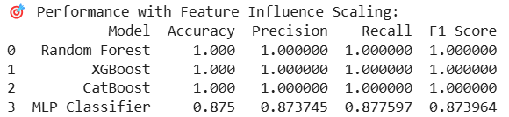

Num_examples

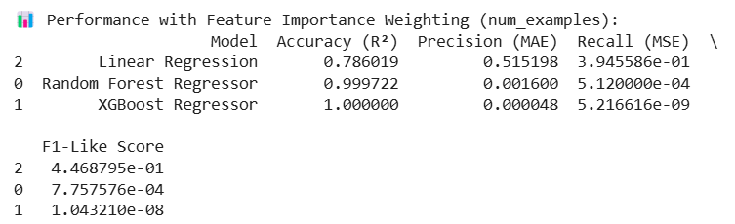

Break_interval

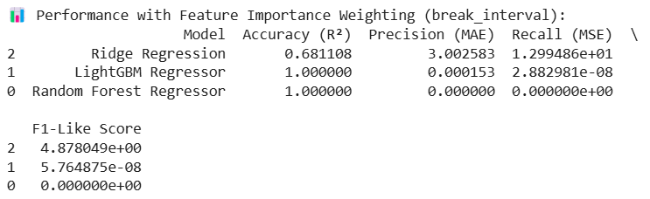

Num_test_questions

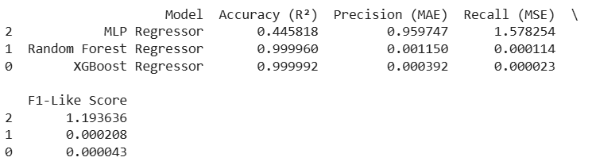

Course_duration

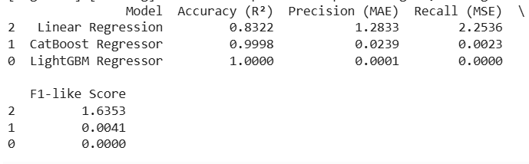

Course name

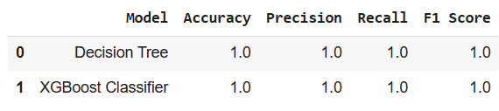

Feature Importance

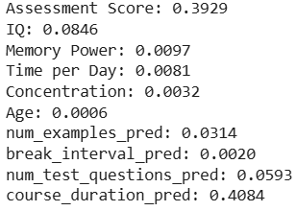

Meta-feature model

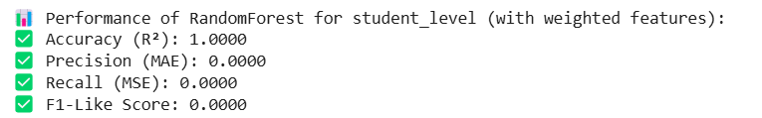

**4. Deployment and Integration**

Though the deployment of the system is still in progress, we have prepared the system for integration and deployment. The following outlines the steps and the modules we have worked on so far:

1. Current State of Deployment

The trained models have been evaluated and are ready for deployment. The primary next step is to expose these models via an API that would allow real-time predictions based on user inputs. Although the backend API setup is not yet complete, the system architecture is designed for easy integration.

Planned Deployment:

API for Real-Time Predictions: Once the backend is fully functional, the models will be served through an API built using a framework like Flask or FastAPI. This API will process the user input, run the predictions, and return personalized learning recommendations.

Cloud Deployment: For scalability, we plan to deploy the application on platforms such as Heroku, AWS, or Google Cloud.

2. Frontend - HTML Pages

In preparation for the deployment, we have designed three important HTML pages that serve as the user interface for interacting with the system. These pages will be integrated into the final application:

Homepage (Landing Page):

The homepage serves as the entry point of the system. It provides an overview of the system and allows users to navigate to other sections. This page presents information on the project and its objectives, and it provides links to the login page and form-filling page.

Key features:

Welcome message and introduction to the system.

Navigation buttons for login and form submission.

Login Page:

The login page is designed to authenticate users before they can proceed to fill in their details. Although the authentication mechanism has not been fully implemented yet, the page design allows for easy integration of login functionality.

Key features:

Fields to input username and password.

Basic form submission mechanism for user authentication.

Form-Filling Page:

On this page, users enter their personal information (such as age, IQ, concentration, etc.) that will be used for the model’s predictions. The input data will be sent to the backend API once the API is integrated. The page layout is designed to be simple and user-friendly.

Key features:

Input fields for personal details, such as age, IQ, memory power, etc.

A submit button to send the data to the backend API for prediction.

These HTML pages are essential for gathering user input, authenticating users, and presenting the results of the predictions. The frontend will be fully integrated with the backend API in the future.

Output:

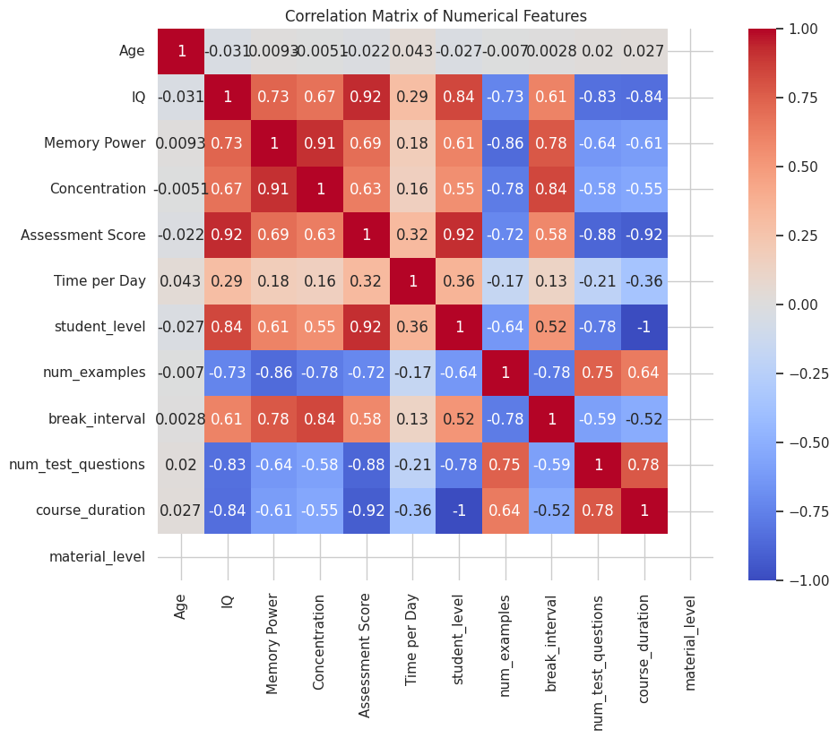 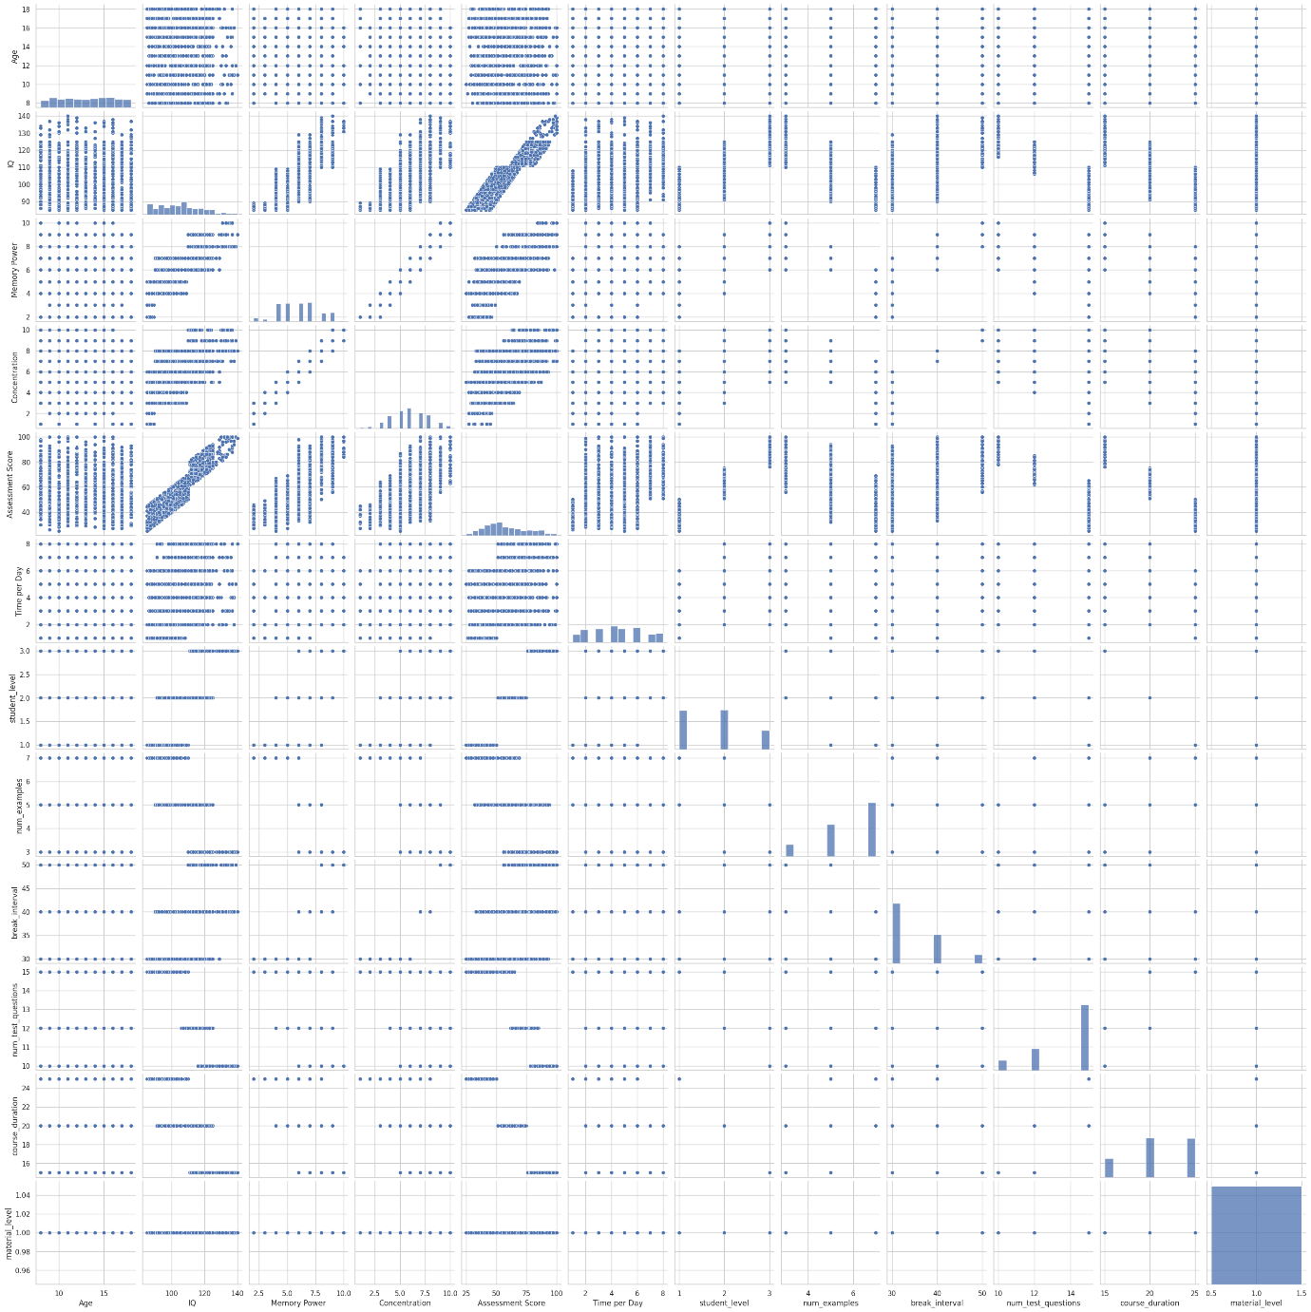

**Homepage**

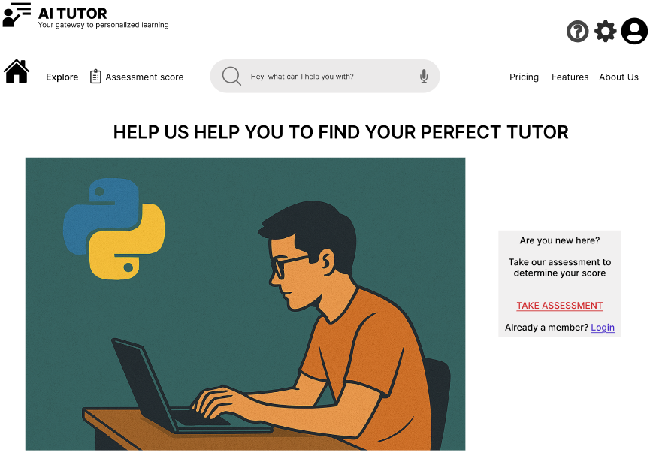

**Login Page**

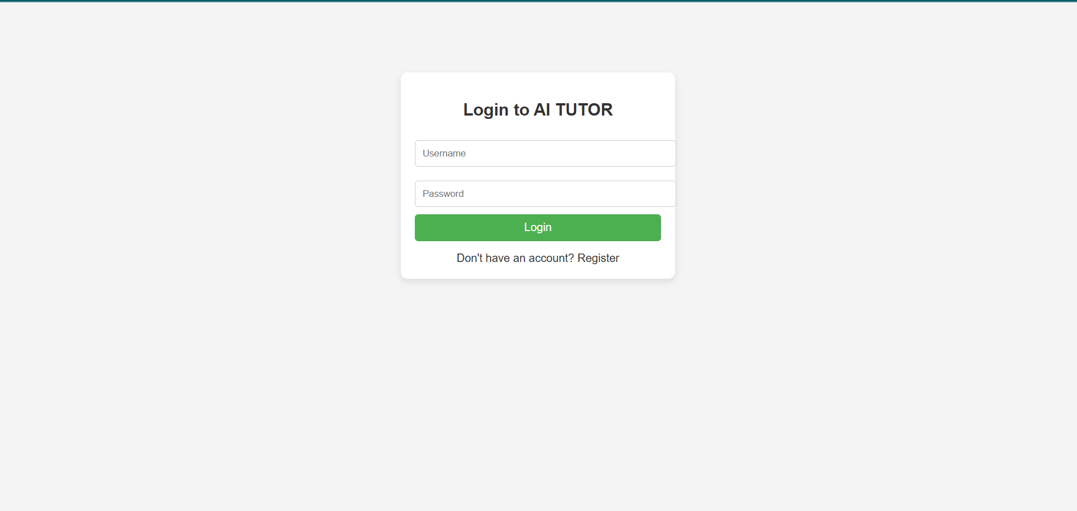

**Registration Page**

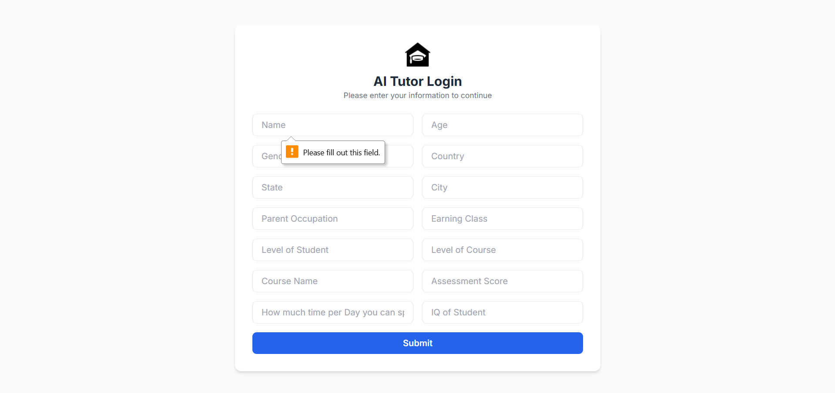

**Sample Output**

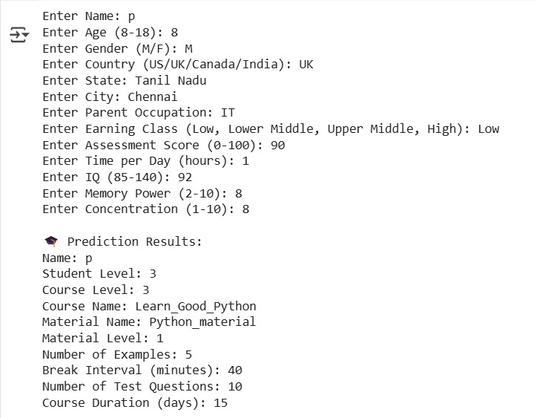

**Concentration test Assessment**

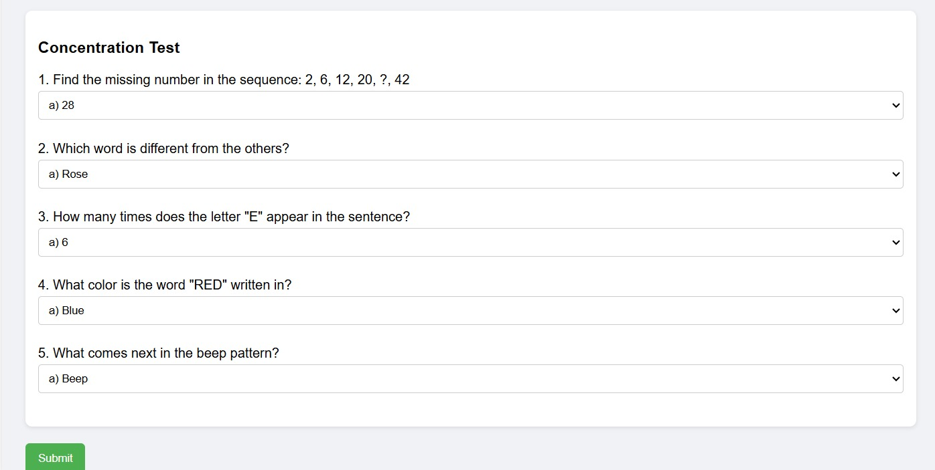

**Levels of Course**

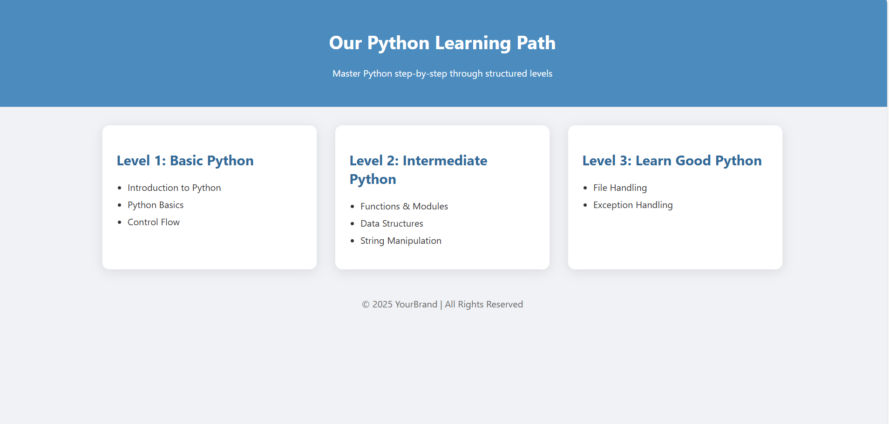

**FAQs**

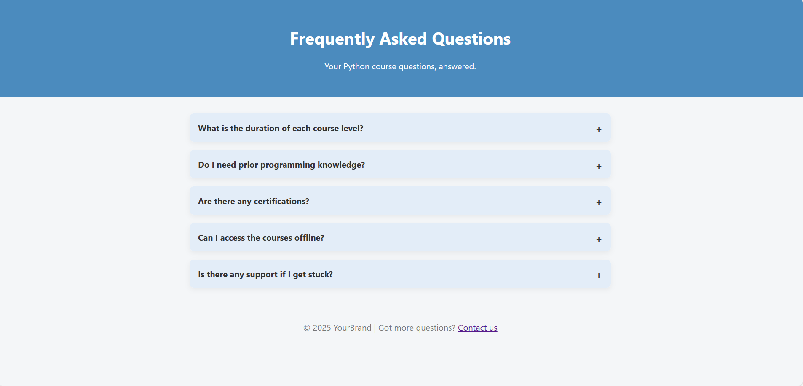

**Courses - Basic**

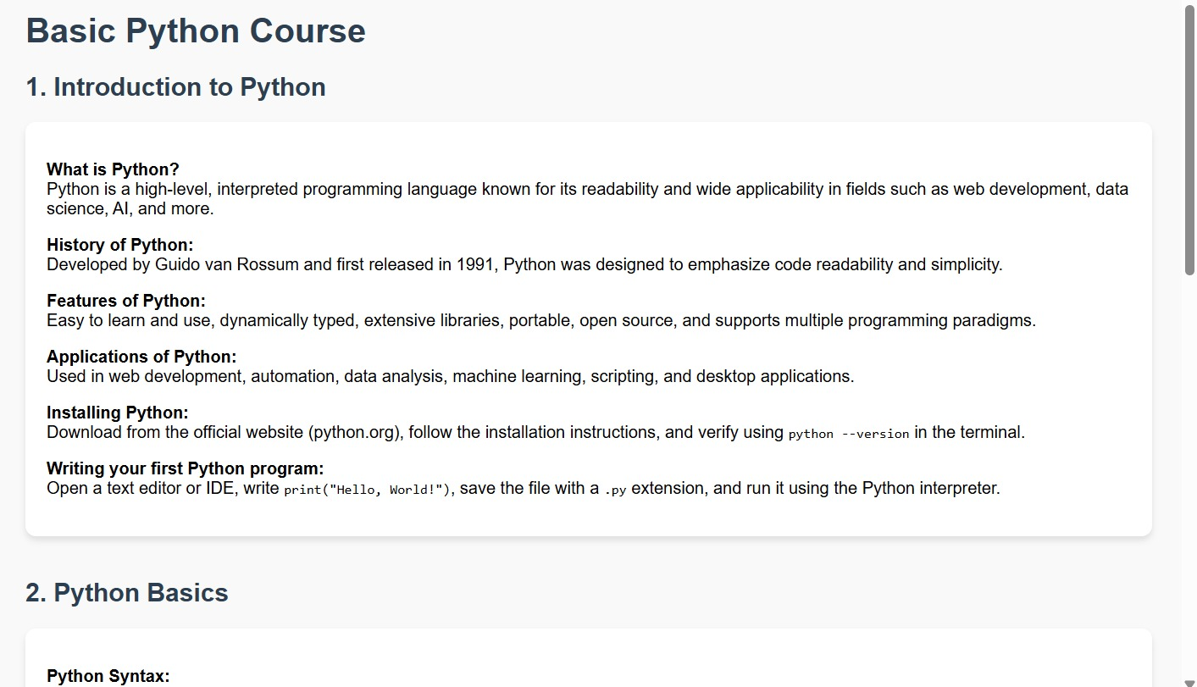

**Intermediate**

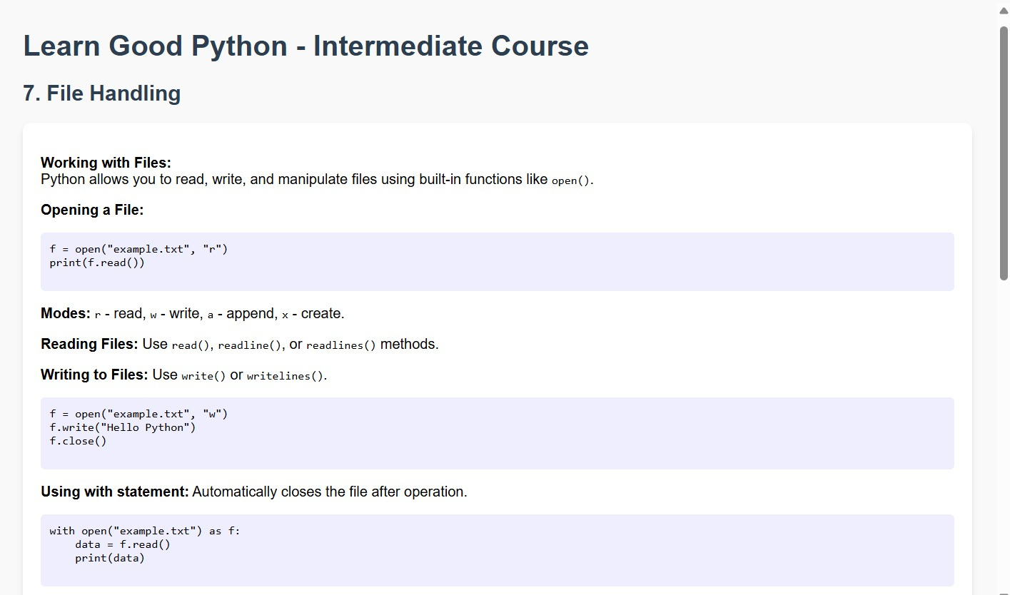

**Learn-good Python**

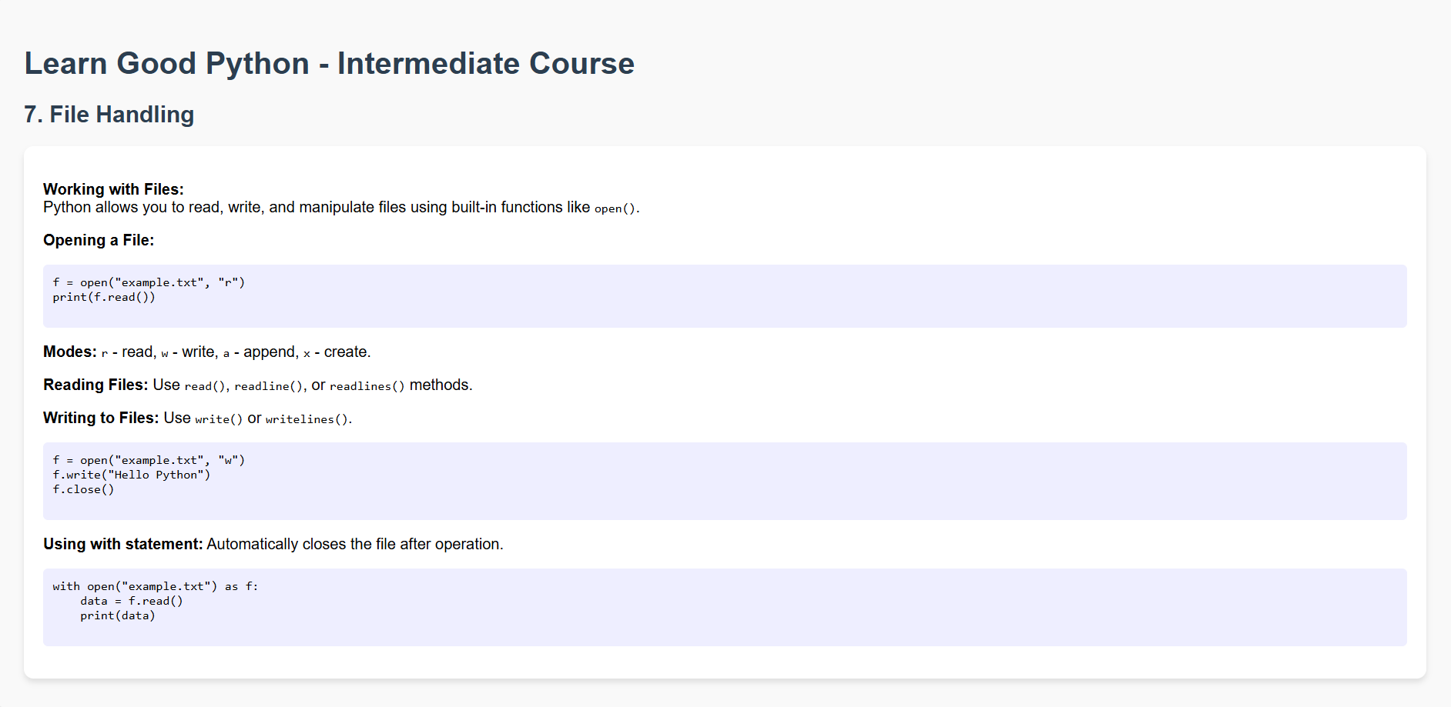

**Challenges and Future Scope**

**5.1 Challenges Encountered**

While developing and testing the system, several challenges arose, which required creative problem-solving and adaptation. These challenges include:

* Data Quality and Pre-processing:

Collecting accurate, clean, and structured data from students was challenging. The pre-processing phase required significant efforts to handle missing values, outliers, and inconsistencies in the data.

Ensuring that the input features were relevant to the student-level prediction task was key, but there were instances where data from different sources was inconsistent.

* Model Training and Evaluation:

During model training, achieving a good balance between accuracy and over fitting was a challenge. While some models (e.g., Random Forest, XGBoost) showed promising results, fine-tuning them for optimal performance required careful hyper parameter tuning.

Feature engineering also posed a challenge as we needed to scale the features based on their influence on the target variable, but it was not always straightforward to determine the optimal scaling factors.

* Integration of AI Models:

Integrating the trained AI models into a backend system was initially challenging, as it required linking various components (data pre-processing, model inference, and API) into a coherent system.

The need to deploy the models and ensure they are accessible for real-time predictions posed additional technical challenges.

* User Interface Design:

While designing the HTML pages for user input and interaction, it was challenging to ensure a seamless experience between the frontend (HTML pages) and the backend API. We ensured that the frontend pages were designed to be user-friendly, but full functionality will only be achieved once the backend API is integrated.

Handling user input validation and ensuring that the correct data is submitted to the backend was a challenge.

**5.2 Future Scope**

There are several areas for improvement and future expansion, which can help take the project to the next level:

* Backend API Integration:

Real-Time Predictions: The backend API will be developed to handle real-time predictions based on user input. This will include exposing the trained models as RESTful APIs.

User Authentication: Implementing secure user authentication mechanisms (e.g., JWT tokens or OAuth) will help manage users and their data more effectively.

* Model Improvement:

Hyper parameter Tuning: Further optimization of model hyperparameters using techniques like Grid Search or Random Search can improve model performance.

Model Deployment: Once the models are optimized, they will be deployed using cloud-based platforms (like AWS or Google Cloud) for scalability.

Incorporating Additional Data: Future versions of the system could incorporate more personalized data (e.g., past learning behaviour) to improve the predictions further.

* Personalization and Recommendation:

Moving beyond just predicting student-level and course recommendations, future work could involve recommending specific learning paths or resources based on the predicted student performance.

Adaptive learning features can be developed based on the user’s progress, dynamically adjusting the learning content and the course level.

* Web Application and User Experience:

Interactive Frontend: Improve the frontend by creating dynamic, interactive dashboards using frameworks like React or Angular, which would allow for smoother user interaction.

Mobile App Development: Developing a mobile app version of the system would improve accessibility and allow students to access the system on the go.

Advanced Analytics: Include a dashboard that provides insights into the student’s performance, learning habits, and recommendations for improvement.

* Broader Integration:

The system can be integrated with educational platforms or Learning Management Systems (LMS) like Moodle or Blackboard to provide personalized learning experiences across various courses.

The system could also be scaled for educational institutions, where administrators can track the progress of students and make necessary adjustments to course levels and content delivery.

**Conclusion**

In conclusion, the project successfully developed an AI-powered adaptive learning system that personalizes educational content for students based on various parameters. Through this system, we aimed to create a smarter way for students to receive course recommendations, track progress, and optimize their learning journey based on their unique characteristics such as IQ, Assessment Scores, and Study Habits.

Key aspects covered in the project include:

**Data Collection and Pre-processing:**

The data collection process was essential for building a strong foundation for the predictive models. Pre-processing included handling missing data, normalizing inputs, and ensuring that data was structured for model training.

**Feature Engineering and Model Selection:**

We applied feature engineering to identify key influencing factors (e.g., Assessment Score, IQ, Memory Power) and used modelling techniques such as Random Forest, XGBoost, CatBoost, and MLP Classifier to predict the student-level and other related variables. The models were fine-tuned to optimize their performance, resulting in high accuracy for predicting the student level and course recommendations.

**User Interface:**

A simple, user-friendly interface was developed with HTML pages allowing users to input their data. The Homepage, Login page, and Form Filling page were designed to provide a smooth user experience, though further integration with the backend is required for full functionality.

**Models and Technology Used:**

The models were trained using real-world data and implemented using Google Colab, Figma (for UI/UX design), and version-controlled with Git. We also leveraged GPT for potential future integration to enhance personalized learning by creating dynamic, tailored content for students.

**Key Contributions:**

AI-Based Predictions: We built AI models that can predict optimal learning paths for students based on individual inputs.

HTML Interface: The basic interface (Homepage, Login, and Form page) was designed to gather user inputs and display results.

Scalable Learning System: We designed a system that can adapt to various student learning styles and needs, allowing for future improvements.

**6.1 Key Learnings:**

Importance of Data: Clean and well-structured data is the foundation for building accurate models, and the challenges faced in pre-processing highlighted the importance of this stage.

Feature Engineering and Model Tuning: Carefully selecting and scaling features based on their influence significantly improved model performance.

User-Centric Design: Creating an intuitive and accessible user interface is key to ensuring the system can be used effectively by students.

**6.2 Moving Forward:**

With the system designed and the models trained, the next steps involve deploying the models in a live environment, further optimizing the interface, and adding more personalized features like adaptive learning paths and advanced analytics.

In addition, integrating the system with other educational tools and expanding its scope to handle more comprehensive learning data will allow for the creation of a truly adaptive and personalized learning experience for students worldwide.

This project has laid the groundwork for a more intelligent and data-driven approach to education, and with further development and deployment, it has the potential to revolutionize personalized learning systems.

**Future Work and Improvements**

While the project has successfully implemented the core features of the adaptive learning system, several improvements and expansions can be made to enhance the system's capabilities, user experience, and overall functionality. Below are potential directions for future work:

**7.1 Model Enhancement**

Incorporating More Features:

Currently, the models rely on a select set of features such as Assessment Score, IQ, Concentration, etc. Future work can involve integrating more student characteristics, such as learning preferences, student feedback, and study environment factors, to further personalize the learning path.

Additional external data sources such as peer learning scores and time-of-day usage patterns could also be used to improve predictions and learning recommendations.

Advanced Machine Learning Models:

More advanced algorithms like Deep Learning, Recurrent Neural Networks (RNNs), or Reinforcement Learning could be explored to dynamically adapt the learning system based on real-time student interactions.

Transfer learning and model ensembles can be utilized to combine the strengths of multiple models for better predictive accuracy.

**7.2 System Integration**

API Integration:

Developing a backend API to handle real-time user input and processing would allow the system to be integrated into educational platforms, such as Learning Management Systems (LMS).

API endpoints can be used to communicate between the user interface and backend AI models to generate personalized content dynamically.

Mobile Application:

As more users rely on smartphones for learning, a mobile version of the platform could be developed. This version would allow users to interact with the system on the go, making learning more flexible and accessible.

**7.3 User Interface and User Experience (UI/UX)**

* Enhanced Personalization:

While the HTML interface provides basic functionality, further enhancing the UI/UX design would improve user engagement. Features such as real-time progress tracking, gamification, and visual aids (graphs/charts) could be incorporated to make the learning experience more interactive and visually appealing.

* User Feedback Loop:

A feedback system could be implemented where students can evaluate the course, rate the learning experience, and suggest improvements. This would help continually improve the models and the recommendations based on real-time data.

* Speech-to-Text Integration:

Implementing speech recognition tools to allow voice input from users, especially those with disabilities or different learning styles, would make the platform more inclusive and versatile.

**7.4 Data Collection and Privacy**

* Ensuring Data Privacy and Security:

As the system processes personal data (e.g., student age, IQ, etc.), ensuring privacy and data security is of utmost importance. Future work should include implementing proper encryption, anonymization techniques, and compliance with privacy regulations like GDPR and FERPA (Family Educational Rights and Privacy Act).

* Data Augmentation:

To enhance the model's performance, the dataset could be expanded by collecting more diverse and representative data from students worldwide, especially from different educational backgrounds.

**7.5 Scalability and Performance Optimization**

* Cloud Integration:

Hosting the models and data on a cloud platform (like AWS, Google Cloud, or Microsoft Azure) would ensure that the system is scalable and can handle large amounts of data from a growing number of users. This would also allow the system to scale on demand, especially during periods of high user activity.

* Optimizing Model Efficiency:

While the current models perform well, further optimization of the machine learning models for faster inference and lower latency will ensure that the platform delivers near-instant results, especially during high traffic times.

Techniques such as model pruning, quantization, and edge computing (for real-time predictions on mobile devices) could improve the system's overall performance.

**References and Links**

Below are some valuable references and links that guided and contributed to the development of the Adaptive Learning System project.

* **ChatGPT-OpenAI**For various NLP tasks, data analysis, and generating prompts to assist in adaptive learning, we leveraged the capabilities of ChatGPT, an AI language model developed by OpenAI.  
  Link: <https://openai.com/chatgpt>
* **Intel®AI-Tools**  
  Intel’s AI technologies and tools were instrumental in the development of the machine learning models used in the system. Intel’s hardware optimizations for AI processing, such as with Intel® Xeon® processors, helped in accelerating the model training process, ensuring better performance.  
  Link: https://www.intel.com/content/www/us/en/artificial-intelligence/overview.html
* **scikit-learn**scikit-learn is an open-source machine learning library in Python that provided essential tools for data preprocessing, model training, and evaluation. It was heavily used in the Random Forest and MLP models.  
  Link: <https://scikit-learn.org/>
* **XGBoost**XGBoost (Extreme Gradient Boosting) was used for improving the model’s predictive power. It is an optimized implementation of the gradient boosting algorithm that provided excellent results in student-level prediction tasks.  
  Link: <https://xgboost.readthedocs.io/en/stable/>
* **CatBoost**CatBoost is another powerful gradient boosting library that was used for its superior handling of categorical data. It proved useful for improving the accuracy of predictions in the system.  
  Link: <https://catboost.ai/>
* **Figma**Figma played an essential role in designing the user interface (UI) of the adaptive learning platform. It allowed us to visually mock-up the pages, ensuring the user experience was intuitive and visually appealing.  
  Link: <https://www.figma.com/>
* **Google**-Collab  
  Google Collab was used for collaborative coding, model training, and experimenting with various machine learning algorithms. Its cloud-based nature made it easy to share and collaborate in real-time.  
  Link: https://colab.research.google.com/
* **GitHub**Version control, collaboration, and code sharing were managed via GitHub. It provided a seamless platform for code management, tracking changes, and collaboration across the team.  
  Link: <https://github.com/>
* **Kaggle**Kaggle is a platform for data science and machine learning competitions, which provided a wealth of datasets and tutorials that helped fine-tune the machine learning models used in this project.  
  Link: <https://www.kaggle.com/>
* **Microsoft** Azure  
  Azure was explored as a potential platform for cloud deployment of the system. Its AI and machine learning services, such as Azure ML, were considered for integrating models in a scalable, cloud-based environment.  
  Link: <https://azure.microsoft.com/en-us/services/machine-learning/>
* **Intel®-Dev-Cloudfor-AI**For model training and optimization, Intel’s DevCloud provided an efficient and powerful cloud environment with specialized hardware for AI development.  
  Link: https://www.intel.com/content/www/us/en/developer/tools/devcloud-for-ai.html

**DRIVE LINK - DESCRIBING OUR PROJECT:** [**https://drive.google.com/file/d/1yaFuV7JorSYZWKf7jGuaXoLBTOeuLyZr/view?usp=drive_link**](https://drive.google.com/file/d/1yaFuV7JorSYZWKf7jGuaXoLBTOeuLyZr/view?usp=drive_link)